Exploratory Data Analysis (CNCITY)

**Gas Pressure Regulator 1:**

**Electricity 1: (5000 lines)**

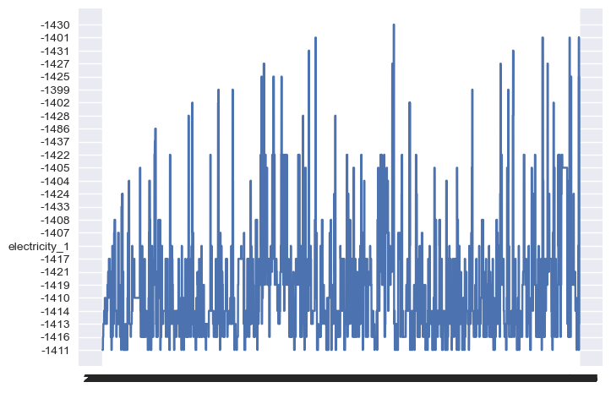

**Linear Regression: (pressure_2, is_maintenance) - epic failure**

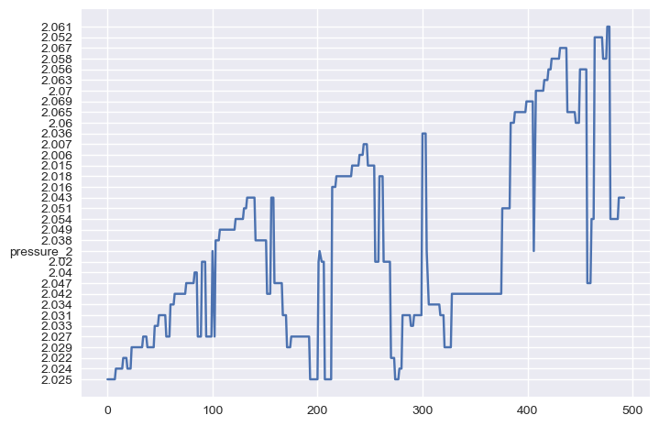

**Key takeaways from this graph:**

* **Since linear regression gives us a float between 0 and 1, logistic regression seems to be a better model when predicting is_maintenance. (is_maintenance is a binomial variable)**
* **It turns out that the ‘is_maintenance’ column is just 0’s**

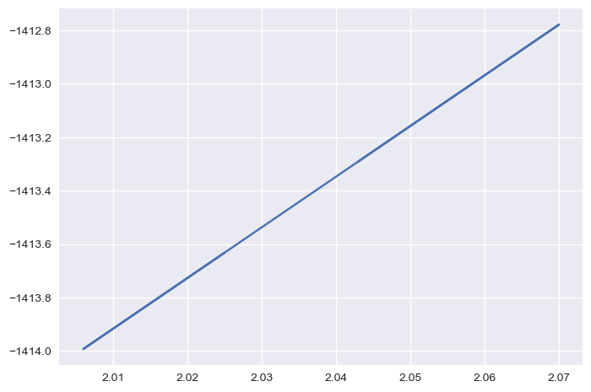

**Ran linear regression with ‘electricity_1’ and ‘pressure_2’**

* **‘Electricity_1’ and ‘pressure_2’ are positively/linearly correlated**

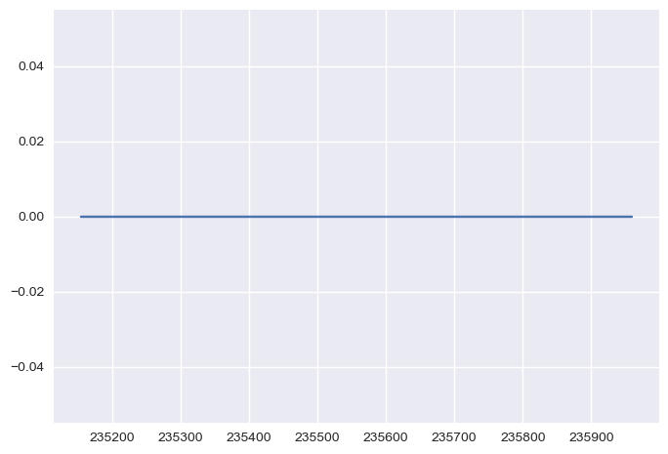

**X label: time, y label: electricity 2**

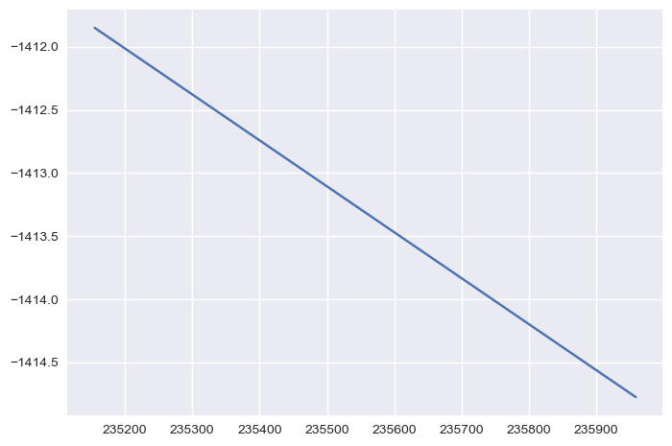

**Linear Regression: time, electricity_1**

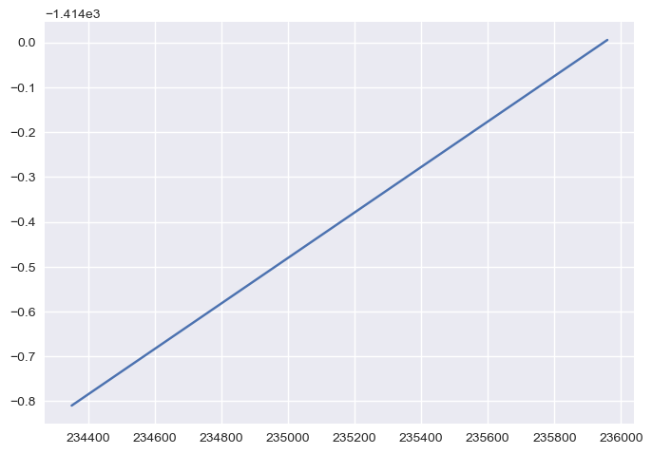

**The graph below is far more informative and intuitive.**

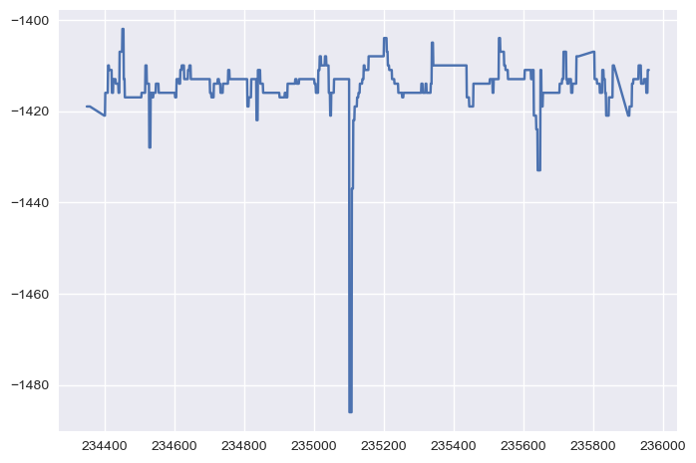

**Pressure_1_status and time**

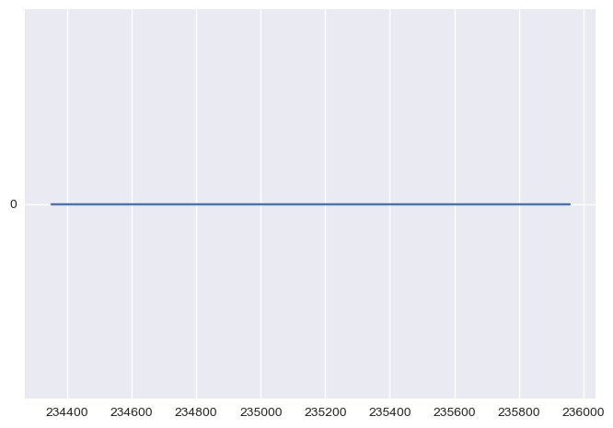

**Pressure_2:**

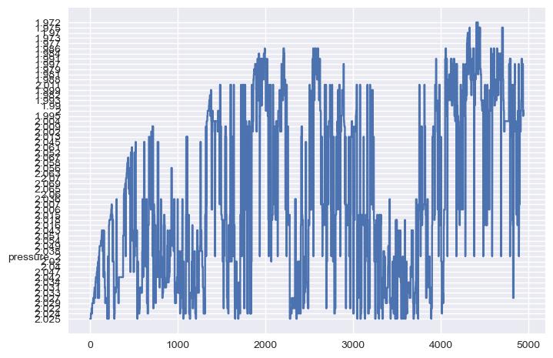

**X axis: time, Y axis: status_electricity_1**

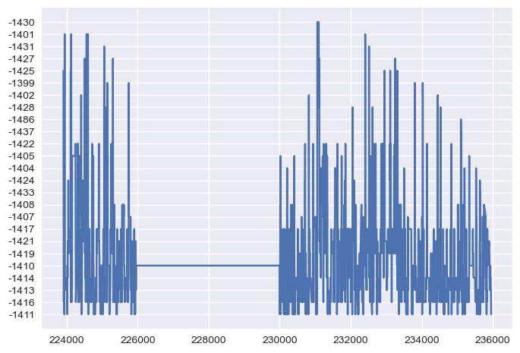

**X axis: time, Y axis: electricity_1**

[**https://www.w3schools.com/python/python_ml_knn.asp**](https://www.w3schools.com/python/python_ml_knn.asp)

**6/11/2024:**

* **Query + connection manager**
* **Table_df (5000+ lines)**